**Video Analysis: Activity 1**

In this activity you will explore the motion graphs of a projectile. You are going to need the software Tracker (<https://physlets.org/tracker/>) and the video of the motion.

1. ~~Import the video into tracker.~~
2. ~~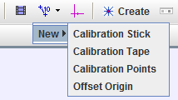Use the black arrows in the sliding bar to select the beginning of the small push we will analyze. Start frame:233 and end Frame: 260.~~
3. ~~Calibrate the video using a Calibration Stick. Set the stick to be one meter long (use the rulers on the video). If you don’t know what calibration find out (you can ask your teacher).~~
4. ~~Show the coordinate system (button next to calibration stick) and place it approximately where the balls is launched.~~
5. ~~Create Point mass~~
6. ~~Go to the first frame where you can see the ball~~
7. ~~Ctrl+Shift+cliclk on the ball~~
8. ~~Make the search area (dotted square around object) large enough so that the ball will be within that square in the next frame.~~
9. ~~Click search next. Continue clicking “search next” while the position is correctly detected. If not, go back by a frame and manually mark it by shift+click on the ball.~~
10. ~~Observe the graph on the right.~~
11. ~~Select the axis you want to plot~~
12. ~~Double click to analyze (for example fit a line of best fit)~~

Now you should be ready to complete the task and answer the questions on the next page.

**Tasks and Questions**

1. Get the graph for the x-coordinate of the ball vs time. Paste it here and describe the type of motion.

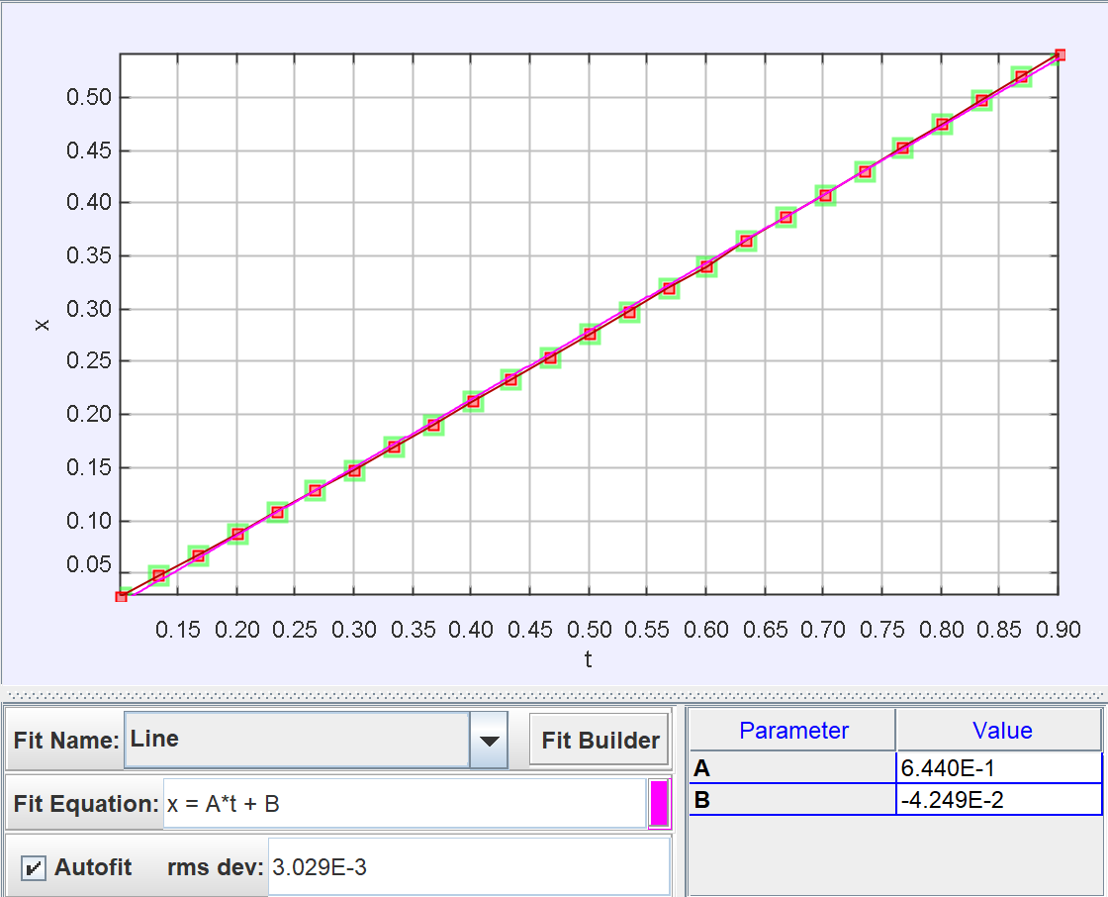

Uniform motion

1. Use the analyze functions to plot a line of best fit and from the coefficients find out the horizontal velocity of the ball in cm/s = 64.4
2. Plot the horizontal velocity vs time. Go to analyze and use the statistics tool to view the mean value. The mean value of the horizontal velocity in cm/s =64.1
3. Are they the same? Why?

They are almost the same. The gradient of the line of best fit x vs t is the mean of the horizontal velocity.

1. Get the graph for the y-coordinate of the ball vs time. Paste it here and describe the type of motion.

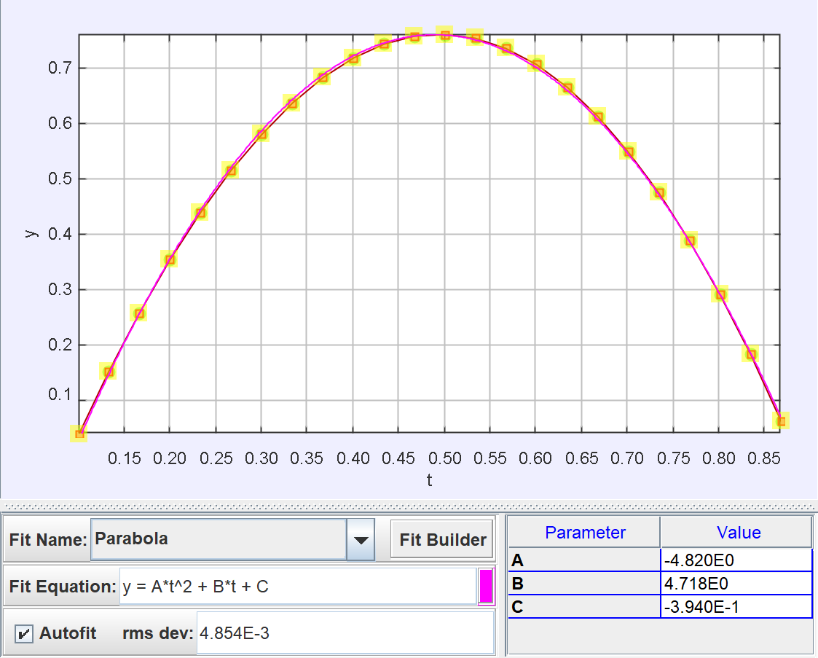 Projectile Motion

1. What equation of motion best describe this graph?

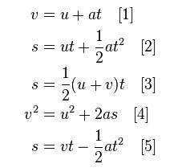

[2]

1. Use the analyze functions to plot a (curved) line of best fit and from the coefficients find out
   1. the value of the vertical acceleration in m/s2 = -9.6
   2. the value of the initial vertical velocity in cm/s=47.2
2. Get the graph for the vertical component of the velocity vs time. Paste it here and describe the type of motion.

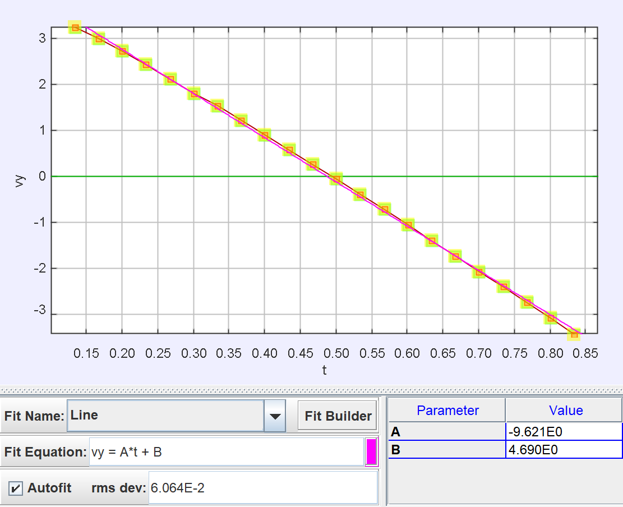

Projectile motion

1. What equation of motion best describe this graph?

[1]



1. Use the analyze functions to plot a line of best fit and from the coefficients find out the value of the vertical acceleration in m/s2 =-9.6
2. Does it match with the previous answer for the acceleration? Why? Is the same as the value of the free-fall acceleration? Why?

Yes. Because acceleration stays the same since gravity if the only force applied on the ball.

Not exactly because of the air resistance.